***Senior Vice-Commander***

Comrades,

Hope everyone enjoyed the holidays and had safe travels.

As you know we are operating under a 710 Inspection at the present time.

Please let me clarify what this means to our Post and all. Let’s all work together and complete this as quickly as possible.

The Veterans of Foreign Wars (VFW) is a non-profit organization that provides support to veterans, service members, and their families. The VFW has a set of guidelines and regulations that each post must follow to maintain its charter and continue to operate.

The VFW Department Inspection Team is responsible for ensuring that each Post is in compliance with these guidelines and regulations.

The team’s mission is to conduct a thorough inspection of the post’s operations, finances, and membership to ensure that it is operating in accordance with the VFW” s rules and regulations.

The team will typically review the post’s records, interview its members, and inspect its facilities to ensure that everything is in order.

If the team finds any issues or discrepancies, it will work with the post to address them and bring the post back into compliance with the VFW’s rules and regulations…. Hope this answers and addresses all concerned.

Until we have our elections at our next meeting Jan. 9th, 2024, for a new Junior-Vice Commander, I will fill both areas with updates of our regular monthly events and dates.

I want all interested people who are willing to work with our present officers and comrades to consider this position.

This is the most intense position in the officer’s workload, (programs, events, Post functions) so be prepared.

I want to thank Commander Rebecca Jackson on her new position and know she is working hard to assist in the work as a post we have encountered.

***Mackie Crossan***

***Commander’s Comments***

Comrades,

My New Year’s wish is for all of us to continue to work together making this the best Post in Texas and All American.

Thank you for your support.

***Rebecca Jackson***

C:\Users\steph\Desktop\VFW-Red-Logo-on-White_Open-Graph.jpg

THE Post script 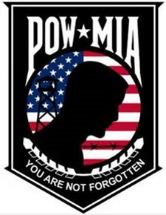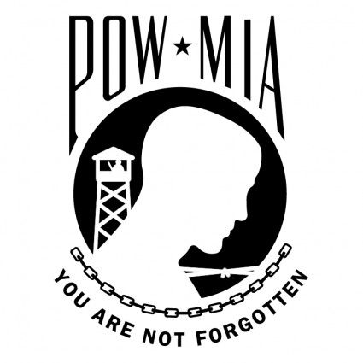

An Official Publication of Martin D. Denson Veterans of Foreign Wars Post 6873, Abilene Texas

***January 2024******Next Meeting – January 9th, at 7:30 p.m. January 2024***



***Service Officer/Chaplain***

VA is asking mortgage companies to hold off on foreclosures for 6 months.

New Year means new beginnings pray for the Post and come support it. Contact me for prayer also as Service Officer.

Please let us know about members in the hospital or who have passed on.

*Leave a lot of happy tracks as you go down life’s road.*

***Charlie Bowen***

***Auxiliary***

Auxiliary Members,

I hope everyone had a happy holiday season. As we start 2024 let us all remember our Veterans and their Families. The Auxiliary still has a few programs we will be working on in the New Year, so please volunteer your time to help. For the January 9th meeting our entree' will be Meatloaf. Please bring a side dish or dessert to share with.

The Mid-winter conference will be January 18-21 in Corpus Christi.

Again, thank you to everyone, your contributions make a real difference in our Post and Auxiliary, I am so thankful for your unwavering support. Thank you for all that you do. God bless!

***Anna Martinez***

***Junior Vice Commander***

These are the dates of upcoming events. If we have left an event off calendar, let us know so we can get it scheduled.

January 2024

Jan 1st, New Years Celebration

Jan 1st, Cooties meeting---7pm

Jan 4th, House Committee meeting—7pm

Jan 9th, Life members meeting—6pm

Jan 9th, Regular members meeting—7:30pm

Jan 18th—22nd, Mid-Winter Conference—Corpus Christi

Jan 28th, Signing of Vietnam Peace Accord—12pm

Senior Vice Commander

Mackie Crossan

LAUNDRY CENTER

SHOWERS & RESTROOM

ACCEPTING ALL

* VFW- AUX MEMBERS
* ACTIVE DUTY
* RETIRED VETERANS
* SPONSORED VFW GUESTS

**Canteen Corner**

**OPEN FOR LUNCH**

Monday-Friday

11:00 AM -2:00 PM

Saturday & Sunday

11:00 AM – 4:00 PM

\_\_\_\_\_\_\_\_\_\_\_\_\_\_\_\_\_\_\_

**Monday**

Meatloaf

$1.00 Jello Shots

**Tuesday**

Hamburger Steak

$3.00 Tequila Sunrise

**Wednesday**

Chicken Fried Steak

$4.00 Humpday Tea

**Thursday**

Chicken Spaghetti

$2.00 Wells

**Friday**

Homemade Catfish

$2.00 Fireball Shots

Daily lunch specials $10 + tax includes sides and may change due to availability.

**Kitchen Open Friday Nights at 7:00 PM - Closing**

**August 2017**

Breakfast served daily  
7:00 a.m. – 10:30 a.m.

**EAT FREE** with a **Breakfast Card** – Visit us for breakfast six times and the seventh visit is **FREE**. See the Canteen Manager.

**Lunch Deals**

Monday – Friday, 10:30 a.m. – 2:00 p.m.

Mondays – Salisbury Steak w/mashed   
 potatoes & green beans

Tuesdays – See Lunch Specials

Wednesdays – Pork chops with 2 sides

Thursdays – Brisket with 2 sides

Fridays – See Lunch Specials

**Lunch Specials**

Lunch Specials are available on Tuesdays and Fridays, 10:30 a.m. – 2:00 p.m.

1st – Mushroom Swiss Burger w/chips

4th – Patty Melt w/chips

8th– Stir Fry w/vegetables

11th – Chicken Broccoli Alfredo

15th – Enchiladas

18th – Chicken Fried Steak

22nd – Lemon Chicken Breast

25th – Rib-eye Tacos

29th – Ribs & Sausage BBQ Plate

**Dinner Deals**

Monday – Friday, 6:30 p.m. – 9:00 p.m.

Mondays – Football Pot Luck

Tuesdays – $8.00 steak with 2 sides

Wednesdays – Patty Melt

Thursdays – VFW Club

Fridays – Beef Nacho Supreme

**Make sure to read your calendar for new happenings at your post.**

***January 2024***



***Important Events***

Jan 1st, New Years Celebration

Jan 1st, Cooties meeting---7pm

Jan 4th, House Committee meeting—7pm

Jan 9th, Life members meeting—6pm

Jan 9th, Regular members meeting—7:30pm

Jan 18th—22nd, Mid-Winter Conference—Corpus Christi

Jan 28th, Signing of Vietnam Peace Accord—12pm

The VFW Post 6873 Bingo is on Facebook. Please “Like” our page to find out Specials and Door Prize announcements.

Prices and game schedules are subject to change.

MONTH OF JANUARY ALL SESSIONS 66 CARD MACHINES $10 – PER SESSION

**Bingo Schedule:**

* Friday & Saturday Nite Time Bingo - Doors open at 7:30 PM, the first game starts at 10 PM. $10 – 66 card machines.
* Paper packs are $4.00, Specials are $2.00, and Double Actions are $1.00.

**Reminder:**

Kitchen will be open on Friday Nights (No outside food or drinks on Friday Nights Sessions). Please, bring your own food and drink on Saturday nights.

No children *under 10* *years old* allowed in the bingo hall. Children 10 thru 18 must be with their parents or guardians and must be playing bingo. Parents will be responsible for their children’s behavior. No unattended children allowed in the parking lot and/or sitting in cars.

**Specials:**

**January 1st – 31ST $10 – 66 CARD MACHINES PER SESSION.**

**BIRTHDAY SPECIAL FREE BIRTHDAY DAUBER & PAY A PENNY FOR A 45 CARD MACHINE PER SESSION (PHOTO ID WITH BIRTHDATE REQUIRED)**

**Monday – Friday 10:00 AM - 3:00 PM**

**Saturday & Sunday 12:00 PM - 5:00 PM**

**Friday & Saturday Nights 8:00 PM - 11:30 PM**

\*Prices and game schedules are subject to change\*

**Taps**

Michael D. Flanders



Phone : (325) 692-0222  
Fax : (325) 692-8244

E-mail: [vfw6873@suddenlinkmail.com](mailto:vfw6873@suddenlinkmail.com)

**Martin D. Denson VFW Post 6873**

1049 Veterans Dr.

Abilene, TX 79605

Return Service Requested